Universal Quantifiers

🌍 What Are Universal Quantifiers?
# Source: AI Source: Provided by: [Data Path: Persons Table -> ID Column: 1, Name_En Column: Motasem Essam] -> From: [ChatGPT] on [7/28/2025]
Universal quantifiers are words that refer to all members of a group — without exception.
They express totality, entirety, or universality.

✅ Common Universal Quantifiers:
# Source: AI Source: Provided by: [Data Path: Persons Table -> ID Column: 1, Name_En Column: Motasem Essam] -> From: [ChatGPT] on [7/28/2025]
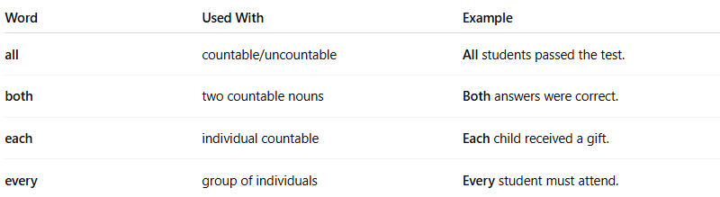
Word | Used With | Example
all | countable/uncountable | All students passed the test.
both | two countable nouns | Both answers were correct.
each | individual countable | Each child received a gift.
every | group of individuals | Every student must attend.

📌 Quick Usage Guide:
# Source: AI Source: Provided by: [Data Path: Persons Table -> ID Column: 1, Name_En Column: Motasem Essam] -> From: [ChatGPT] on [7/28/2025]
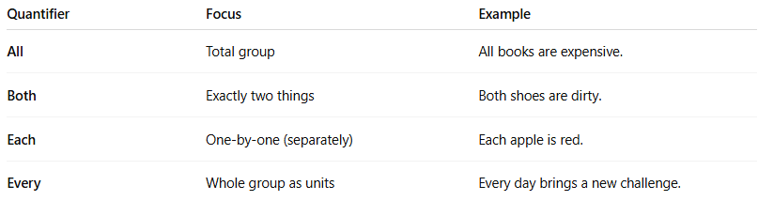
Quantifier | Focus | Example
All | Total group | All books are expensive.
Both | Exactly two things | Both shoes are dirty.
Each | One-by-one (separately) | Each apple is red.
Every | Whole group as units | Every day brings a new challenge.

🧠 Note:
# Source: AI Source: Provided by: [Data Path: Persons Table -> ID Column: 1, Name_En Column: Motasem Essam] -> From: [ChatGPT] on [7/28/2025]
- "Each" focuses on individuals separately.
- "Every" focuses on the group as a whole.

